ALL FOLDERS AND DATASETS OF ANALYTICS VIDYA ARE IN THIS SAME DIRECTORY ONLY BUT THEY ARE HIDDEN

**Variables | Intro 02:37**

* Numerical variables 05:03
* Categorical variables 03:43
* Date and time variables 01:58
* Mixed variable
* Variable characteristics 02:43
* Missing data 06:46
* Cardinality - categorical variables 05:03
* Rare Labels - categorical variables 04:54
* Linear models assumptions 09:13
* Linear model assumptions - additional reading resources (optional) 00:35
* Variable distribution 05:08
* Outliers 08:27
* Variable magnitude

**Introduction to missing data imputation 03:58**

* Complete Case Analysis 06:46
* Mean or median imputation 07:53
* Arbitrary value imputation 06:42
* End of distribution imputation 04:53
* Frequent category imputation 06:56
* Missing category imputation 04:05
* Random sample imputation 14:17
* Adding a missing indicator 05:26
* Mean or median imputation with Scikit-learn 10:33
* Arbitrary value imputation with Scikit-learn 05:35
* Frequent category imputation with Scikit-learn 03:48
* Missing category imputation with Scikit-learn 02:46
* Adding a missing indicator with Scikit-learn 04:06
* Automatic determination of imputation method with Sklearn 08:24
* Introduction to Feature-engine 05:10
* Mean or median imputation with Feature-engine 04:51
* Arbitrary value imputation with Feature-engine 03:30
* End of distribution imputation with Feature-engine 04:46
* Frequent category imputation with Feature-engine 01:38
* Missing category imputation with Feature-engine 02:57
* Random sample imputation with Feature-engine 02:28
* Adding a missing indicator with Feature-engine

**Multivariate Imputation 03:31**

* KNN Impute 04:22
* KNN Impute – Demo 07:04
* MICE 07:07
* missForest 01:07
* MICE and missForest – Demo

**Categorical encoding | Introduction 06:49**

* One hot encoding 06:09
* Important: Feature-engine version 1.0.0 00:22
* One-hot-encoding: Demo 14:12
* One hot encoding of top categories 03:06
* One hot encoding of top categories | Demo 08:35
* Ordinal encoding | Label encoding 01:50
* Ordinal encoding | Demo 08:08
* Count or frequency encoding 03:11
* Count encoding | Demo 04:33
* Target guided ordinal encoding 02:50
* Target guided ordinal encoding | Demo 08:30
* Mean encoding 02:22
* Mean encoding | Demo 05:31
* Probability ratio encoding 06:13
* Weight of evidence (WoE) 04:36
* Weight of Evidence | Demo 12:38
* Comparison of categorical variable encoding 10:36
* Rare label encoding 04:31
* Rare label encoding | Demo 10:25
* Binary encoding and feature hashing

**Variable Transformation | Introduction 04:48**

* Variable Transformation with Numpy and SciPy 07:38
* variable Transformation with Scikit-learn 07:03
* Variable transformation with Feature-engine

**Discretisation | Introduction 03:01**

* Equal-width discretisation 04:06
* Important: Feature-engine v 1.0.0 00:17
* Equal-width discretisation | Demo 11:18
* Equal-frequency discretisation 04:13
* Equal-frequency discretisation | Demo 07:16
* K-means discretisation 04:13
* K-means discretisation| Demo 02:43
* Discretisation plus categorical encoding 02:54
* Discretisation plus encoding | Demo 05:45
* Discretisation with classification trees 05:05
* Discretisation with decision trees using Scikit-learn 11:55
* Discretisation with decision trees using Feature-engine 03:48
* Domain knowledge discretisation
* Outlier Engineering | Intro 07:42
* Outlier trimming 07:21
* Outlier capping with IQR 06:24
* Outlier capping with mean and std 04:44
* Outlier capping with quantiles 03:17
* Arbitrary capping

**Feature scaling | Introduction 03:43**

* Standardisation 05:30
* Standardisation | Demo 04:38
* Mean normalisation 04:01
* Mean normalisation | Demo 05:20
* Scaling to minimum and maximum values 03:23
* MinMaxScaling | Demo 03:00
* Maximum absolute scaling 03:01
* MaxAbsScaling | Demo 03:44
* Scaling to median and quantiles 02:45
* Robust Scaling | Demo 02:03
* Scaling to vector unit length 05:50
* Scaling to vector unit length | Demo

<https://towardsdatascience.com/feature-engineering-for-machine-learning-3a5e293a5114>

<https://www.freecodecamp.org/news/feature-engineering-and-feature-selection-for-beginners/>

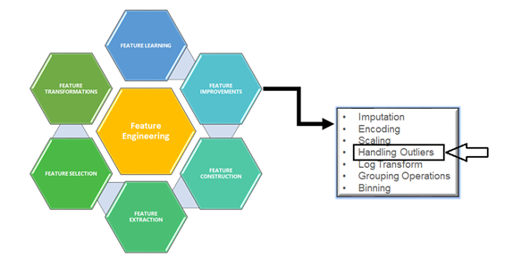

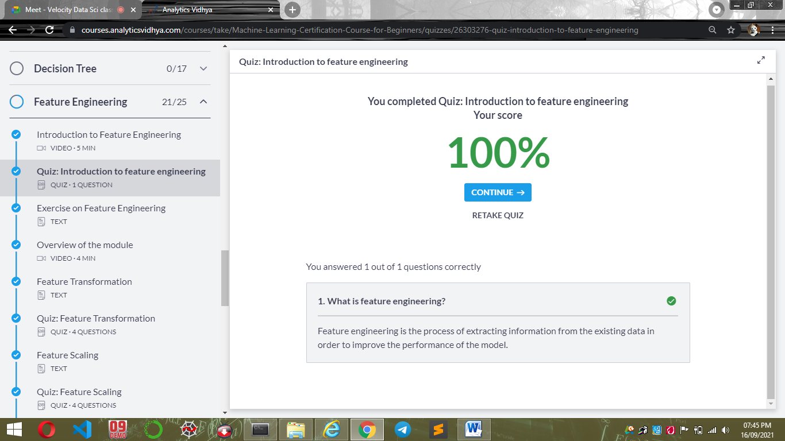

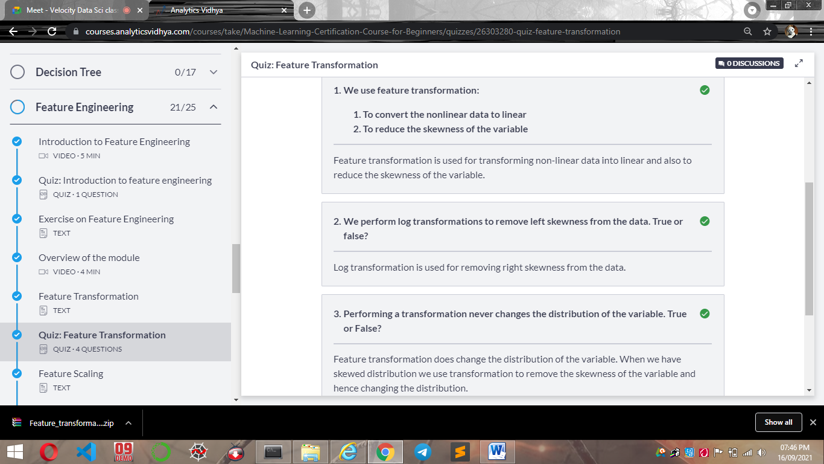

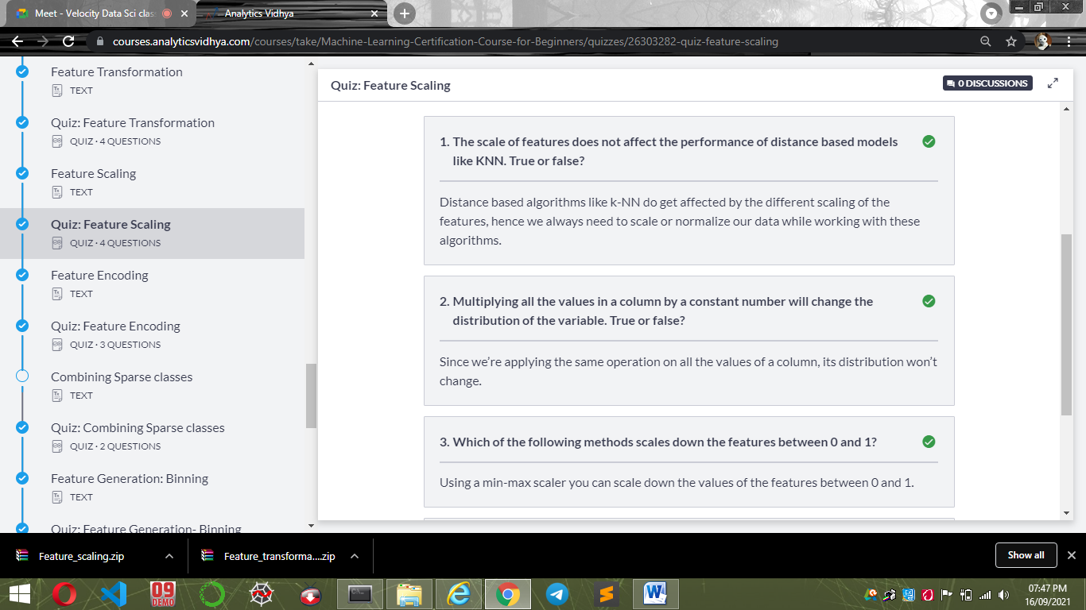

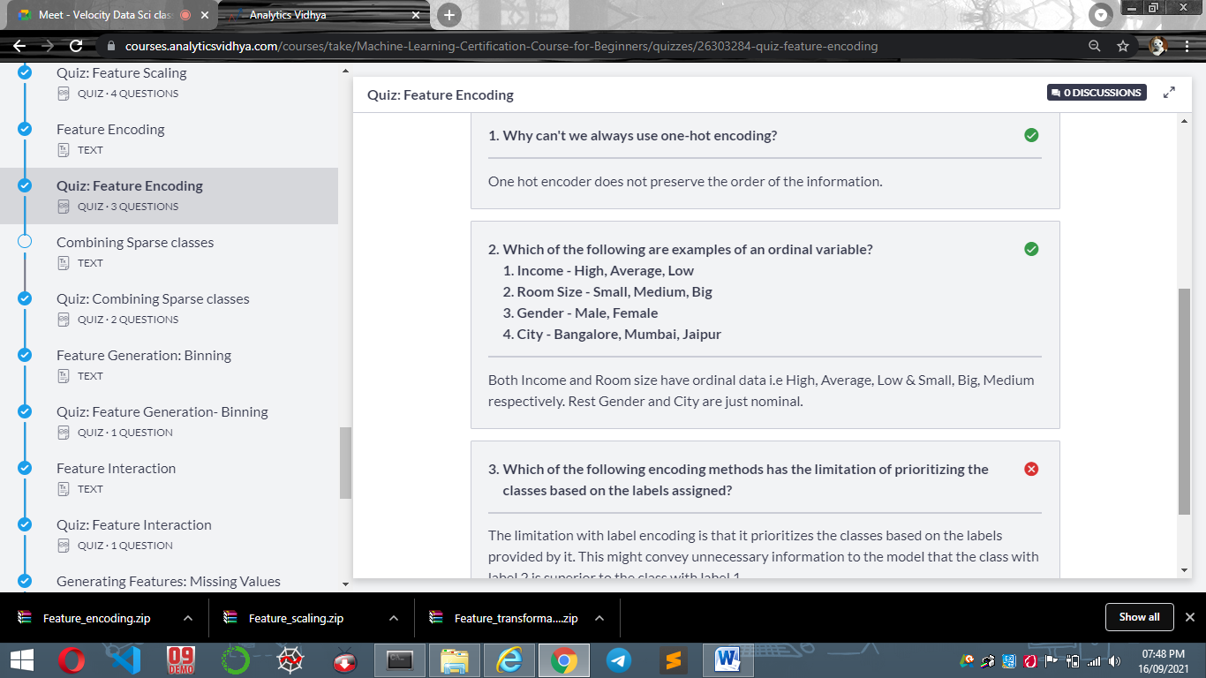

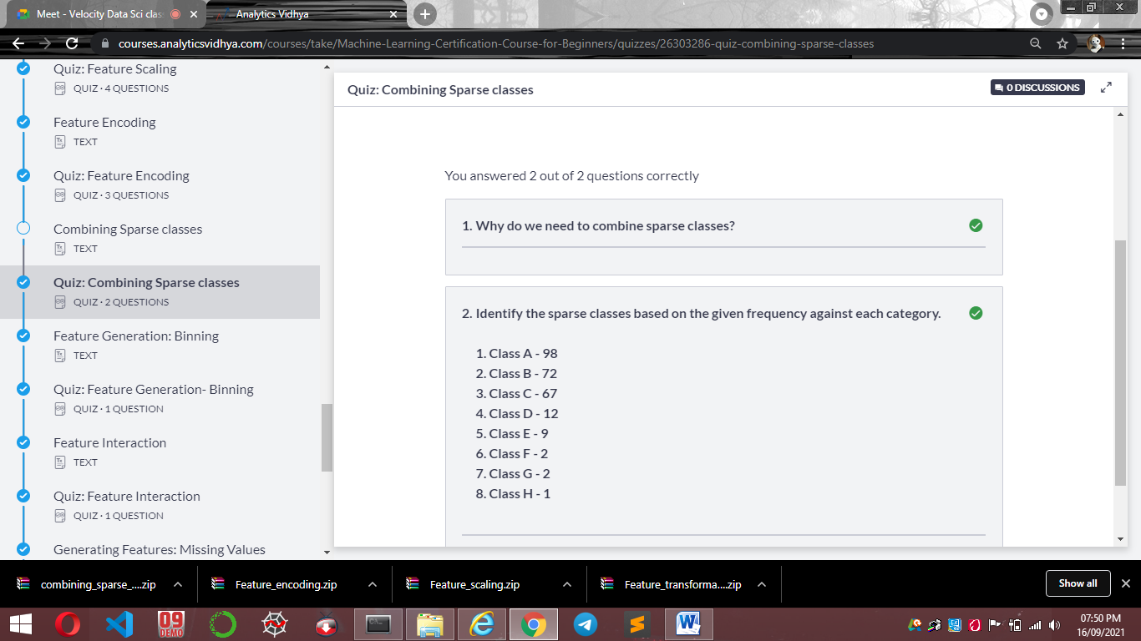

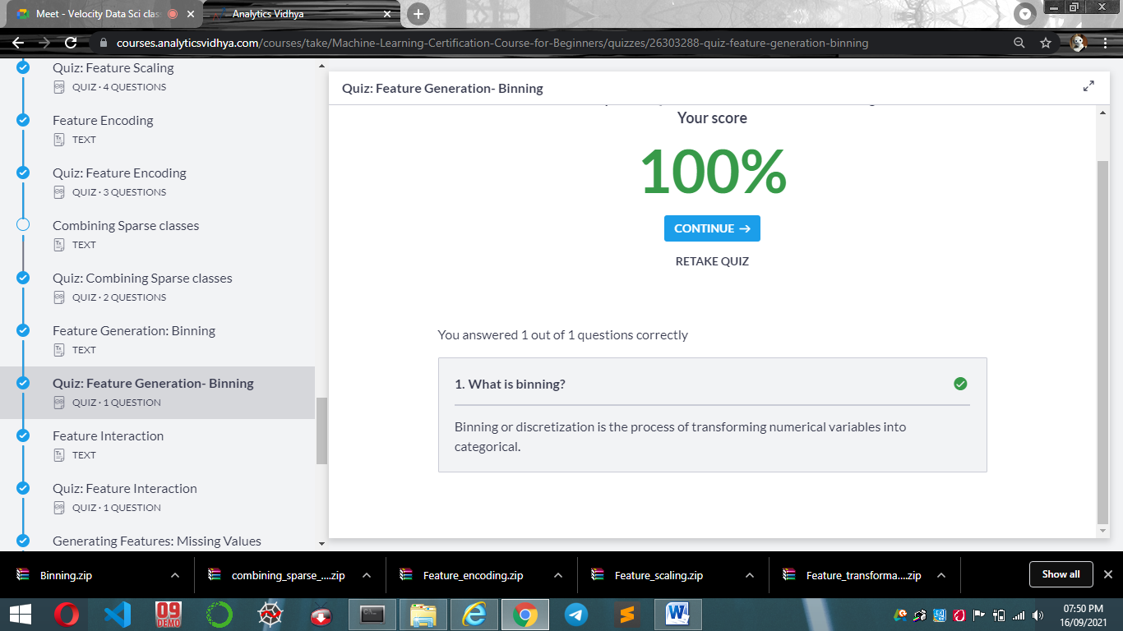

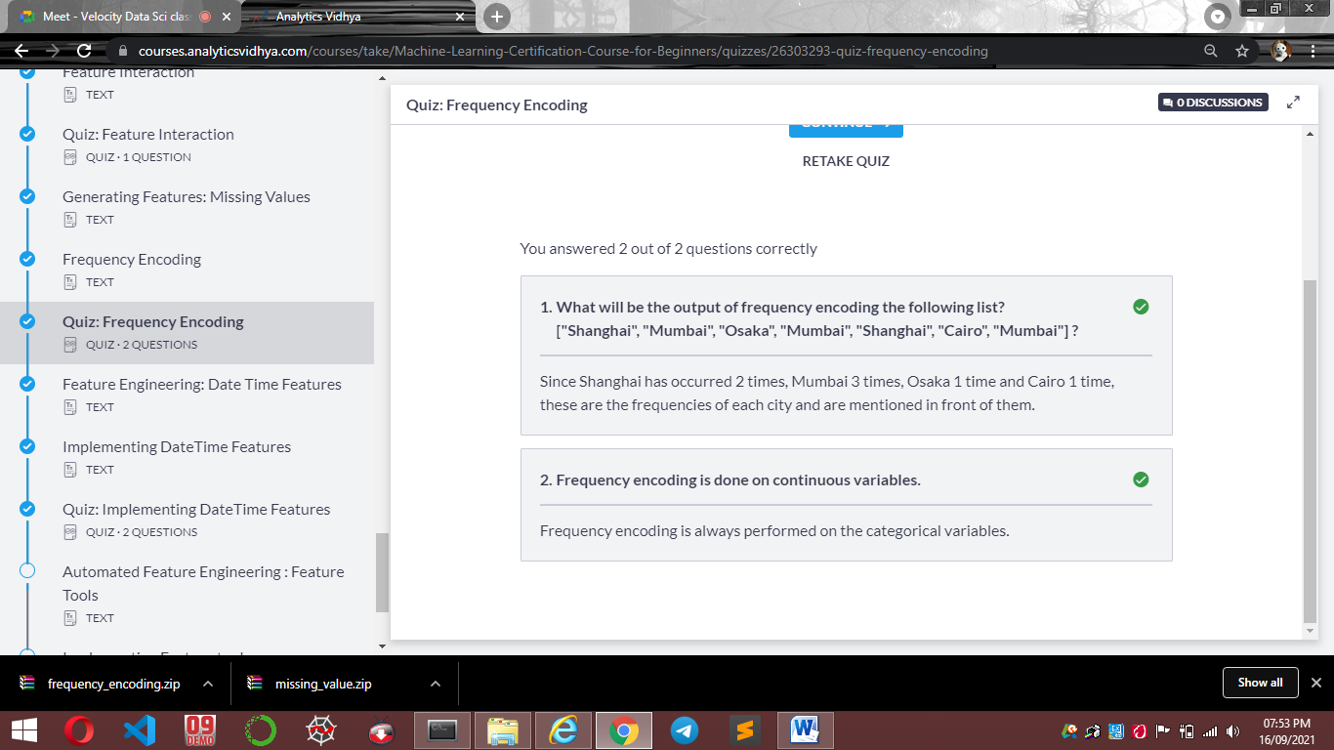

<https://pandas.pydata.org/pandas-docs/stable/reference/series.html#datetime-properties>

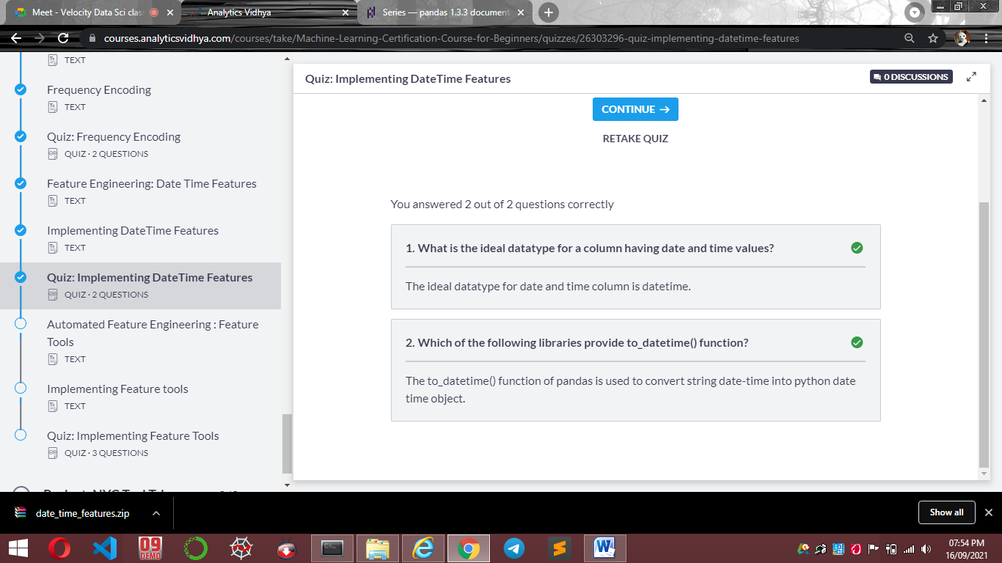

<https://featuretools.alteryx.com/en/stable/>

